CONTENTS:

1) FIRMWARE UPLOAD.

2) USB CONNECTON.

3) I2C COMMUNICATION EXAMPLE.

4) SERIAL COMMUNICATION EXAMPLE.

5) HARDWARE DESIGN.

1)FIRMWARE UPLOAD (Drag and drop)

1.1)Configure the board for serial downloader mode.

Set SW7 switch to OFF-OFF-OFF-ON.

|  |
| --- |
| C:\Users\Enrico\AppData\Local\Microsoft\Windows\INetCache\Content.Word\SW4.jpg |

1.2) Connect the USB cable to the DAP-Link.

|  |
| --- |
|  |

1.3) Press SW3 to reset the processor.

1.4)Drag and drop the binary image located in the following path: “IMX\_MULTIPROTOCOL/FIRMWARE/DRAG&DROP/IMX\_MULTIPROTOCOL\_vXX.bin” to the RT-1020-EVK drive.

|  |
| --- |
| C:\Users\Enrico\AppData\Local\Microsoft\Windows\INetCache\Content.Word\Drag_and_DROP.JPG |

1.5)Put the board back in internal boot mode.

Set SW7 switch to OFF-OFF-ON-OFF.

|  |
| --- |
| C:\Users\Enrico\AppData\Local\Microsoft\Windows\INetCache\Content.Word\SW3.jpg |

1.6)Press SW3 to reset the processor and your application should boot.

1.7) The GREEN Led on RT-1020-EVK should blink four time every 2 seconds.

If device does not blink, repeat the procedure from step 1.

2) USB CONNECTON

2.1)Unplug the DAP-Link USB cable.

2.2)Be sure that J1 is set in the following position.

|  |
| --- |
|  |

2.3) Plug the USB connector on the top of RT-1020-EVK board.

|  |
| --- |
| C:\Users\Enrico\AppData\Local\Microsoft\Windows\INetCache\Content.Word\IMG20210521210447.jpg |

2.4)Device should be detected from your computer.

|  |
| --- |
| C:\Users\Enrico\AppData\Local\Microsoft\Windows\INetCache\Content.Word\ComFOUND.JPG |

2.5) Open Hercules SETUP utility software. Set the serial parameters as follow:

NAME: the com of your device.

BAUD: 115200

DATA size: 8

Parity: none

Handshake: OFF

Mode: Data

2.6) Press the OPEN button.

*NOTE:*

The GREEN led outputs the status of the USB connection.

* 2 blink continuosly: The board is running correctly the application firmware but the USB connection is not established.
* 1 blink continuosly: The board is running correctly the application
* firmware and the USB connection to the device is performed.

2.7)If device is connected, you should see and output string from the RT-1020-EVK.

*NOTE:*

* If device does not receive any commands, it periodically indicates to the user that it is connected and running via a text message.

|  |
| --- |
|  |

3)I2C COMMUNICATION EXAMPLE:

Here we will describe the procedure to write and read from I2C memory.

|  |  |
| --- | --- |
| Device: | Microchip 24LC512 I2C Serial EEPROM |
| Material: | - Breadboard.  - 2x 10k seristor.  - Jumper wires. |
| Test Conditions: | - Pin A0 must be connected to GND.  - Pin A1 must be connected to GND.  - Pin A2 must be connected to GND.  - Pin Vcc must be connected to J20 pin 4 (DCDC\_3V3).  - Pin Vss must be connected to J20 pin 7 (GND).  - Pin WP must be connected to J20 pin 4 (DCDC\_3V3).  -Pin SCL must be connected to J18 pin 6 (SCL).  -Pin SDA must be connected to J18 pin 5 (SCL). |
| Write Data  Following the datasheet the write operations must be permormed as follow:  STEP1:  Set the slave address by sending the command <i2c –a 0x50>.  STEP2:  Set the master in write mode by sending the command <i2c –mt>.  STEP3:  Set the Address high byte by sending the command <i2c –w 0x00>.  STEP4:  Set the Address low byte by sending the command < i2c –w 0x00>.  STEP5:  Set the data to be stored in the memory by sending the command <i2c –w 0x01>.  STEP6:  Enable I2C by sending the command <imx –i>.  STEP6:  Start I2C transfer by sending the command <imx –x>.  *NOTE:*  For a complete description of commands follow the document “*IMX\_MULTIPROTOCOL – Command\_Reference*” avaliable in the repository.  The follwing image is showing what is going on on the bus. | |
| Read Data  Following the datasheet the write operations must be permormed as follow:  STEP1:  Set the slave address by sending the command <i2c –a 0x50>.  STEP2:  Set the master in write mode by sending the command <i2c –mt>.  STEP3:  Set the Address high byte by sending the command <i2c –w 0x00>.  STEP4:  Set the Address low byte by sending the command < i2c –w 0x00>.  STEP5:  Send the address in read mode by sending the command <i2c –mt>.  STEP6:  Request a byte read by sending the command command <i2c –r>.  STEP6:  Enable I2C by sending the command <imx –i>.  STEP6:  Start I2C transfer by sending the command <imx –x>.  *NOTE:*  For a complete description of commands follow the document “*IMX\_MULTIPROTOCOL – Command\_Reference*” avaliable in the repository.  C:\Users\Enrico\AppData\Local\Microsoft\Windows\INetCache\Content.Word\SCR04.png  The follwing image is showing what is going on on the bus. | |

4)SERIAL COMMUNICATION EXAMPLE:

Here we will describe the procedure to talk with SIM800C modem.

|  |  |
| --- | --- |
| Device: | KS0254 SIM800C SHIELD |
| Material: | - Jumper wires. |
| Test conditions: | - Connect the RX pin of the modem to TX pin of RT-1020-EVK (J17 pin 1).  - Connect the TX pin of the modem to RX pin of RT-1020-EVK (J17 pin 2). |
| Data transfer  STEP1:  Set the serial baudrate to 9600 by sending the following command <ser –b2>.  STEP2:  Enable UART by sending the command <imx –s>.  *NOTE:*  For a complete description of commands follow the document “*IMX\_MULTIPROTOCOL – Command\_Reference*” avaliable in the repository.  The follwing image is showing received data from the modem. | |

5) HARDWARE DESIGN:

A printed circuit board compatible with RT-1020-EVK Arduino connector is made avaliable for the project.

It incorporrates additional visual functions (leds) and basic protections for the communication lines.

Bom and schematic diagram are located in the GIT repository “*IMX\_MULTIPROTOCOL/HARDWARE/..*”

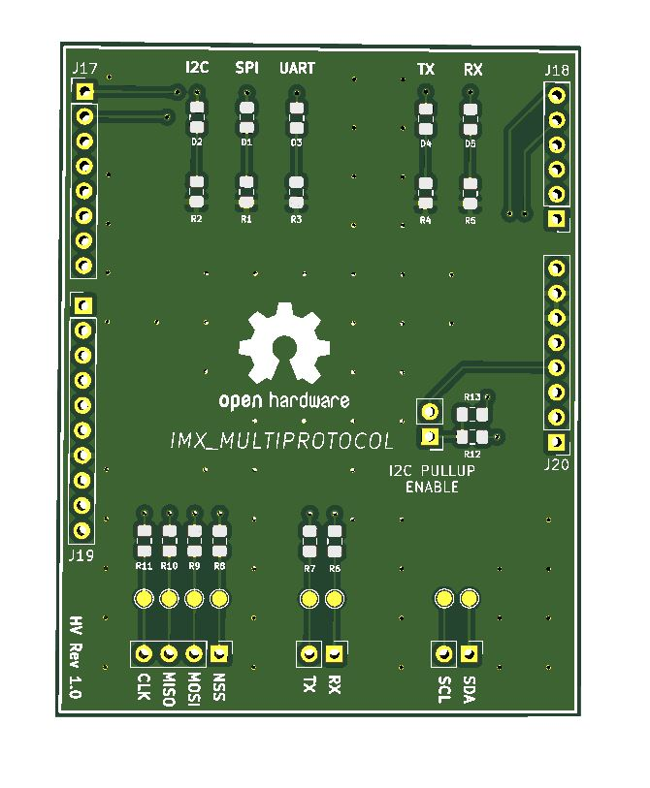

(TOP view)

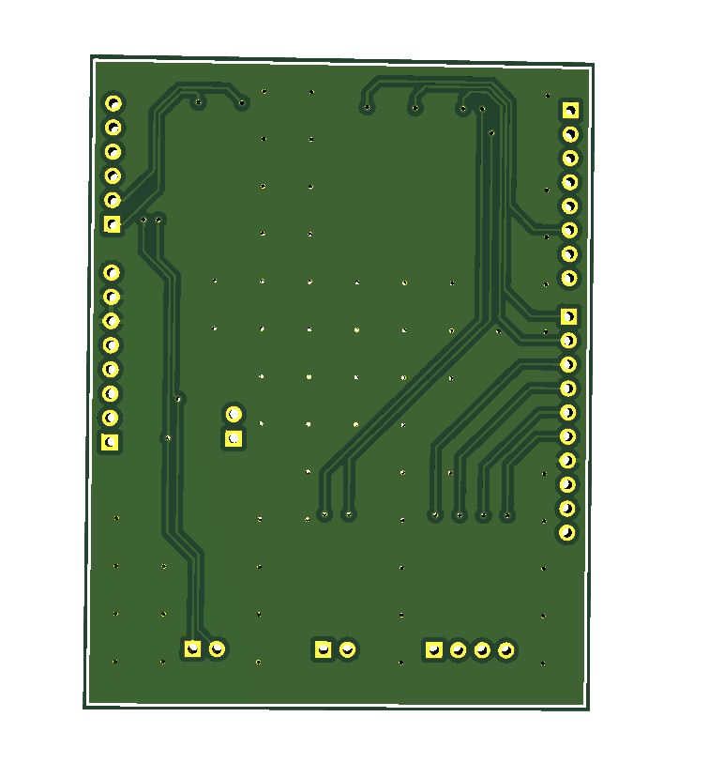

(BOTTOM view)

|  |  |
| --- | --- |
| INFORMATION FOR FABBRICATION PROCESS | |
| BOARD DIMENSION | 68,60mm x 53.30mm |
| RACCOMENDED THICKNESS | 1,6mm |
| MIN TRACK SPACING | 6mil |
| MIN HOLE SIZE | >0.3 mm |

|  |  |  |
| --- | --- | --- |
| REVISION HISTORY | | |
| VERSION | REVISION DATE | COMMENTS |
| 1 | 04/06/2021 | First Release |